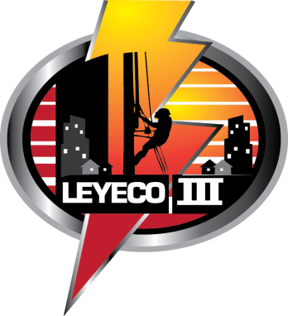
LEYTE III ELECTRIC COOPERATIVE, INC.
(LEYECO III)
Brgy. San Roque, Tunga, Leyte
Tel. No. (053) 542-3103 to 04 Telefax No. (053) 331-8522
E-mail Address: leyteiiie@yahoo.com

MEMORANDUM OF UNDERTAKING

Know all men by these presents:

This Memorandum of Undertaking executed and entered into in Tunga, Leyte by and between:

__________________________________________ of legal age, single, married, widow/er, with residence address at ______________________________________________________ hereinafter referred to as the OWNER;

and,

__________________________________________ of legal age, married, widow/er, presently residing at __________________________________________________________ hereinafter called the TENANT or SECOND PARTY.

WITNESETH:

That the OWNER temporarily assigns to the TENANT/SECOND PARTY by virtue of the Lease Contract, ______________________________________________ (others, please specify) the name of the electric service connection to be installed at _________________________________________________________________________________________.

That upon the effectivity of the Lease Contract or agreement, the aforementioned TENANT/SECOND PARTY act in behalf of the OWNER being the occupant of said premises;

That the TENANT/SECOND PARTY, as occupant of the premises, accepts the responsibility to pay the monthly electric consumption to the Leyte III Electric Cooperative, Inc. (LEYECO III);

That any default of payment of TENANT/SECOND PARTY shall cause automatic disconnection of electric service after prior notice have been served;

That for any reason, aforesaid TENANT/SECOND PARTY failed to pay the electric bill, the OWNER shall be jointly and solidarily LIABLE of the TENANT’s/SECOND PARTY’s unpaid account.

IN WITNESS HEREOF, the parties hereunto sign this undertaking this _________ day of ____________________________________ in Tunga, Leyte.

____________________________________________ ____________________________________________
OWNER TENANT/SECOND PARTY
(Signature over Printed Name) (Signature over Printed Name)

WITNESSES:

____________________________________________ ____________________________________________
(Signature over Printed Name) (Signature over Printed Name)

ACKNOWLEDGEMENT

Before me, a Notary Public, this ________ day of _________________________________ at ______________________________, personally appeared the above-named persons known to me and to me know to be the same persons who executed the foregoing instrument and acknowledged that the same are their own free and voluntary act and deed.

Witness my hand and notarial seal.

____________________________________________ NOTARY PUBLIC
Doc. No. ___________
Page No. ___________
Book No. ___________
Series of ___________

